1. What does the Dollar($) sign do?

Answer

**A dollar sign in Excel is used for absolute cell referencing. This tells Excel that you want to always refer to a specific cell even when your formula is copied across.**

**Let me explain:**

**What is cell referencing?**

**A cell reference is simply telling Excel the location of the cell (or cells) you want to use in your formula.**

**There are two types of cell referencing: relative cell referencing and absolute cell referencing.**

**As pictured below, in cell B5 we have the value of 10. The formula in B5 is =A5*B4**

**This formula is telling Excel we want to multiply the value in A5, which is 10, with the value in B4 which is 1 (10 x 1 = 10)**

**Notice there is no dollar sign used in this formula – this is called a relative cell reference**

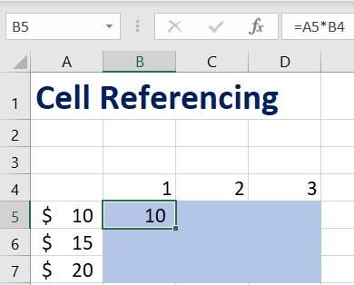

**So what happens when we copy this formula across a range of cells?**

**As pictured below, in cell C5 we have the value of 20. The formula in C5 is =B5*C4**

**This formula is telling Excel we want to multiply the value in B5, which is 10, with the value in C4 which is 2 (10 x 2 = 20)**

**Notice that after copying the formula, it no longer points to column A. Instead, Excel has copied the relative formula style: the cell to the left multiplied by the cell above (highlighted in red)**

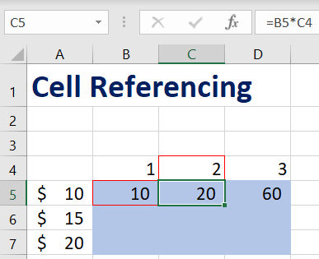

**If you want your formula to always refer to a specific cell, e.g. cell A5, when it is copied across, you need to use absolute cell referencing.**

**This is where the dollar sign comes in.**

**In cell B5, we will use the formula =$A$5*B4**

**Adding a dollar sign in front of both the A and 5 that make up cell A5 sets both Column A and Row 5 as absolute.**

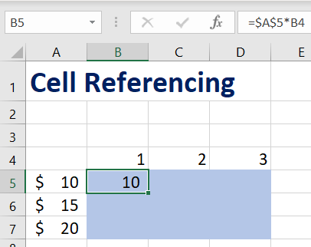

**You can set rows and columns to be absolute depending on your needs**

**A1: Both the column and row will change.**

**$A1: The column will always point to A, but the row will change.**

**A$1: The column will change, but the row will always point to 1.**

**$A$1: Both the column and row will remain pointed to A1.**

2. How to Change the Reference from Relative to Absolute (or Mixed)?

Answer

**For more Information Refer Above Question**

**We can change cell Reference from Relative to Absolute or Mixed by** **Adding a dollar sign in front of both the Row and Column that make up cell sets both Column and Row as absolute**

**And For mixed add Dollar($) in front of column or row**

**A1: Both the column and row will change. (Relative Ref)**

**$A1: The column will always point to A, but the row will change. (Mixed ref)**

**A$1: The column will change, but the row will always point to 1. (Mixed ref)**

**$A$1: Both the column and row will remain pointed to A1 (Absolute Ref)**

3. Explain the order of operations in excel?

Answer

**Microsoft Excel evaluate the formulas from Left to Right following a particular Operator precedence.**

* **Parentheses ‘( )’ are evaluated at first,**
* **then Exponentiation ‘^’,**
* **Multiplication or Division ‘* or /’ (whichever comes first),**
* **Addition or Subtraction ‘+ or -’ (again whichever comes first),**
* **then Concatenation (joining strings) ‘&’**
* **and finally, Comparison.**

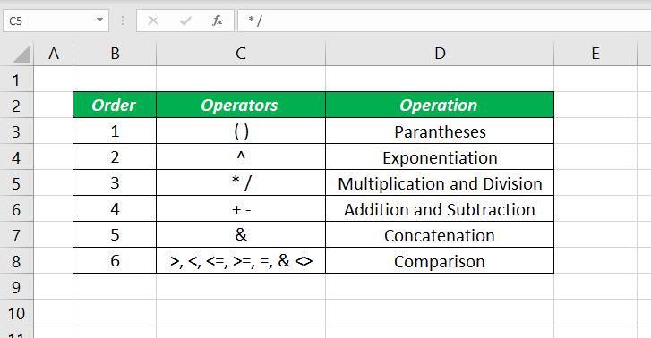

**Basically, it uses BODMAS Ruel for Order Of Operation**

4. What, according to you, are the top 5 functions in excel and write a basic syntax for any of two?

Answer

**The Top Five Functions in Excel According to Me is**

* [VLOOKUP **Formula**](https://gofishdigital.com/blog/5-excel-functions-you-should-know/#VLookupFormula)
* [**Concatenate Formula**](https://gofishdigital.com/blog/5-excel-functions-you-should-know/#Concatenate)
* [**Text to Columns**](https://gofishdigital.com/blog/5-excel-functions-you-should-know/#Text)
* [**Remove Duplicates**](https://gofishdigital.com/blog/5-excel-functions-you-should-know/#Duplicates)
* [**Pivot Tables**](https://gofishdigital.com/blog/5-excel-functions-you-should-know/#Pivot)

[**Concatenate Formula**](https://gofishdigital.com/blog/5-excel-functions-you-should-know/#Concatenate) **:**

**let’s say you want to have the city and state in one column. Perhaps you want to analyse the data by city, but there are cities with the same name in different states so you need them combined. The concatenate function is an incredibly easy formula that you can use to combine the contents of different cells.**

**First, you’ll need to add a new column to your table, which is where the new combined data will live**

**Final formula:**

**=CONCATENATE (C2,”, “,D2)**

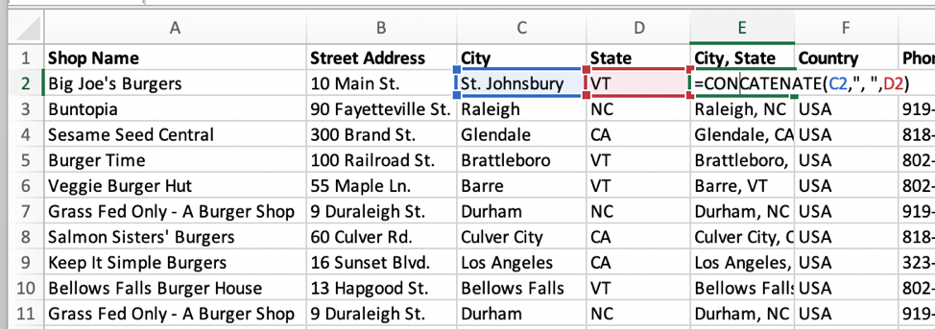

**Text to Columns:**

**Let’s say you have city and state combined for each burger shop, but you’d like them in separate columns. The “Text to Columns” function is a simple way of breaking data into multiple columns based on certain criteria. It can separate text based on a space or a certain delimiter, such as a dash or comma.**

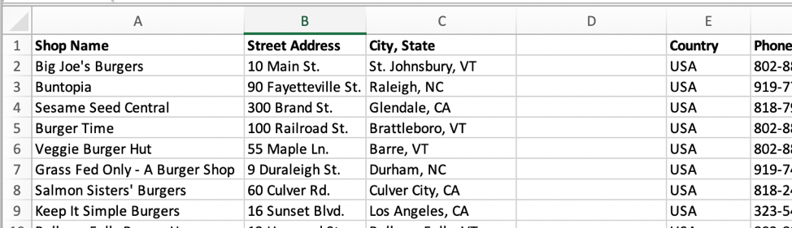

**Add a column to the right of the column you’re separating (or multiple columns if you’re separating the data into more than two sections) like in the screenshot above and then follow instruction**

* **Highlight the entire column with your text to be separated (in this case it’s column C)**
* **Click the “Data” tab in the toolbar**
* **Click “Text to Columns”**
* **Confirm that “Delimited” is selected**
* **Click “Next”**
* **Then select the delimiter that applies**

5.When would you use the subtotal function?

**SUBTOTALS help us to get the totals of several columns of data broken down into various categories**

6.What is the syntax of the VLOOKUP function? Explain the terms in it?

VLOOKUP is powerful Excel function that is often overlooked. Users will find it useful when they need to find specific data on a large table. You can also use VLOOKUP to search for names, phone number, or specific data on your sheet. Instead of manually looking for the names and wasting time scrolling through hundreds of data, the  [VLOOKUP function](http://spreadsheeto.com/vlookup/) makes this process faster and more efficient.

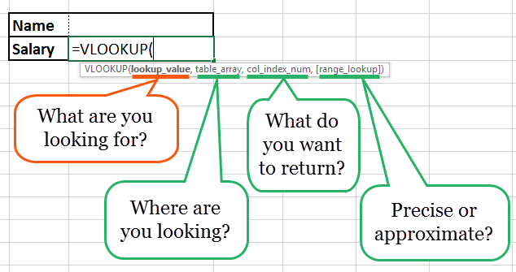

The VLOOKUP formula is “=VLOOKUP” (lookup value, table array, col_index_num, *range lookup*).

* “lookup value” is the data you want to find.
* “table array” is the data column where you want to limit your search.
* “col_index_num” is the column number within the table that you want to return a value from.
* “range lookup” is an optional argument that allows you to search for the exact match of your lookup value without sorting the table.